Example of creating a table in schema called new_database. This table will be an example of what the tables holding items such as parks and hotels will be. This table will designed to hold the hotels in Brisbane city. As such the columns of the tables will be based on that. The table is called Museum.

This script below is what is the MYSQL script used to create a table called museum with a number of tables and columns.

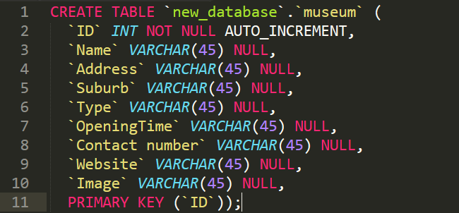

As can be seen from this script the columns of the table are; Name, Address, Suburb, Type, Opening time, contact number, website and image. The primary key is the ID.